SoCaLS Community Newsletter  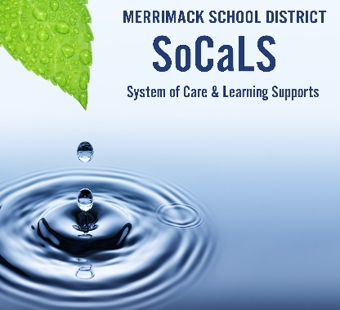 | December 2021
The end of 2021 will soon be here, and it feels like yet another significant marker during these “COVID” times. Endings and new beginnings signal that a transition is upon us. Transitions can be a special time of opportunity and celebration, reflection, and renewal.

However, it is important to remember that transitions also can be incredibly challenging for many us, young and old. There are lots of “zigger-zaggers” as our routines change, and energy levels are high during a holiday season filled with celebration. From a brain-based perspective, transitions require extra vigilance, as things are a bit more uncertain and unpredictable. In fact, the brain may interpret transitions as a threat.

How can we soothe the anxious brain? Take it “low and slow,” breathe, talk about our emotions, and be transparent about any changes in routines. When we return from vacation, take the time to re-teach rituals and routines both at home and at school!

Upcoming Events! Save the Dates!  Registration for Events for Parents will be Posted on Websites!  January 13th, 18th, 20th:  Mindfulness for Families with Whitney Tave – 3, ½ hour sessions from 6:30-7 to learn more about using mindfulness to support self-regulation.  January 25th : Suicide Prevention Training with Special Guests from NAMI-NH.  First Tuesdays and Thursdays: February – May, 6:30-7:15: Brain-Based Parenting with Dr. Alison Roy  For Secondary Students:  2/1, 3/8, 4/5, 5/3  For Elementary Students:  2/3, 3/10, 4/7, 5/5  February 15th: Screening of ANGST (Film about anxiety)  March 16th and March 30th: 7-8:30  Dr. Peg Dawson: Supporting Adolescent Executive Functioning  May 12th: Justice John Broderick – The Campaign to Change Direction  TBD: Screening of LIKE (film about Social Media Addiction) | Did You Know…  - In January, NH will have a statewide centralized mental health crisis call system and the ability to deploy mobile mental health crisis teams to all regions of the state  - In July, the National Suicide Hotline will be changed to 988. This will enable people to reach a crisis counselor with an easy to remember number  - To connect with non-crisis resources and support in NH, call NAMI at 800-242-6264 or dial 211  For 24/7 crisis support, visit: https://www.naminh.org/resources-2/crisis-lines/, call the National Suicide Prevention Lifeline – answered locally by Headrest in Lebanon, NH at 1-800-273-8255, or text NAMI to 741741.  -  Check out the Community Helpers flier for information about supports available for families.

